Technical Report Standard Page

1. Title and Subtitle
Enter Title and Subtitle
2. Author(s)
Enter Authors
3. Performing Organization Name and Address
Affiliation or department
Physical address or university name
City, State, Zip
4. Sponsoring Agency Name and Address
Louisiana Department of Transportation and Development
P.O. Box 94245
Baton Rouge, LA 70804-9245
5. Report No.
FHWA/LA.23/Enter 3-digit Report No.
6. Report Date
Enter Report date
7. Performing Organization Code
LTRC Project Number: LTRC #
SIO Number: SIO #
8. Type of Report and Period Covered
Enter Type of Report
Enter Date: Month/Year – Month/Year
9. No. of Pages
Enter number of pages

10. Supplementary Notes
Conducted in Cooperation with the U.S. Department of Transportation, Federal Highway Administration
11. Distribution Statement
Unrestricted. This document is available through the National Technical Information Service, Springfield, VA 21161.
12. Key Words
Enter key words/phrases, separated by semicolons
13. Abstract
Enter Abstract

Project Review Committee
Each research project will have an advisory committee appointed by the LTRC Director. The Project Review Committee is responsible for assisting the LTRC Administrator or Manager in the development of acceptable research problem statements, requests for proposals, review of research proposals, oversight of approved research projects, and implementation of findings.
LTRC appreciates the dedication of the following Project Review Committee Members in guiding this research study to fruition.

LTRC Administrator/Manager
[Enter name]
[Enter field of research]Research Manager

Members
Enter member’s names, one per line

Directorate Implementation Sponsor
Chad Winchester​, P.E.
DOTD Chief Engineer

Enter Report Title Here
By
Principal Investigator
Co-principal Investigator
Affiliation or department
Physical address or university name
City, State, Zip
LTRC Project No. Enter format 00-000
SIO No. Enter format 000-00-0000
conducted for
Louisiana Department of Transportation and Development
Louisiana Transportation Research Center
The contents of this report reflect the views of the author/principal investigator who is responsible for the facts and the accuracy of the data presented herein.
The contents do not necessarily reflect the views or policies of the Louisiana Department of Transportation and Development, the Federal Highway Administration or the Louisiana Transportation Research Center. This report does not constitute a standard, specification, or regulation.
Enter Month Year

Abstract
Click or tap here to enter text.

Acknowledgements
Click or tap here to enter text.

Implementation Statement
Click or tap here to enter text.

Table of Contents
Technical Report Standard Page 1
Project Review Committee 2
LTRC Administrator/Manager 2
Members 2
Directorate Implementation Sponsor 2
Enter Report Title Here 3
Abstract 4
Acknowledgements 5
Implementation Statement 6
Table of Contents 7
List of Tables 8
List of Figures 9
Introduction 10
Literature Review 11
Objective 12
Scope 13
Methodology 14
Sample Use of Format Styles (Heading 3) 15
Samples: Tables 17
Sample Figures and Graphics 18
Discussion of Results 22
Conclusions 23
Recommendations 24
Acronyms, Abbreviations, and Symbols 25
References 26
Appendix 27

List of Tables
Table 1. Sample LTRC table—basic 17
Table 2. Sample LTRC table—with footnotes 17
Table 3. Sample LTRC table—complex headers 17

List of Figures
Figure 1. Constructed test section on LA 1003 18
Figure 2. Monitoring stiffness reduction of bases using FWD, LFWD, and Geogauge 19
Figure 3. Shrinkage cracks in a micro-cracked section and an untreated section [7] 20
Figure 4. Annual vertical displacements in meters (with matching data table) 21

Introduction
Click or tap here to enter text.

Literature Review
Click or tap here to enter text.

Objective
Click or tap here to enter text.

Scope
Click or tap here to enter text.

Methodology
Click or tap here to enter text.

Sample Use of Format Styles (Heading 3)

Section Heading (Heading 4)
Every darkness yielding. Beast, cattle, there itself waters divide fruitful also that sea land tree likeness creeping. Bold text with Strong character style.
Paragraph Heading (Heading 5). Made created, set. Called fifth there us. Firmament lights so land appear. Italic text with Emphasis character style.

Bulleted lists:
- List bullet
  - Second level bullet
    - Third level list bullet
      - Fourth level list bullet
- List bullet

Numbered lists:
- List number
  - Second level list number
    - Third level list number
      - Fourth level list number
- List number

Samples of References Cited in Body Text
Body text here with sample reference report, [1] body text continues.
Body text here with sample reference journal article, [2] body text continues.
Body text here with sample, reference report [3] body text continues.
Body text here with sample reference, government report [4] and body text continues.
Body text here with sample reference, book [5] body text continues.
Body text here with sample reference, document from a website [6] body text continues.
Body text here with sample reference, article in a periodical [7]

Sample Hyperlinks
Cross-References: See Table 1
URLs: http://www.ltrc.lsu.edu
Email: info@LA.gov

Sample Equations
$a^{2}+b^{2}=c^{2}$ where, [7]
a = insert definition,
b = insert definition, and
c = insert definition.
Or use this alternate method of listing the variables
where, a = insert definition, b = insert definition, and c = insert definition.

Samples: Tables
Table 1. Sample LTRC table—basic
Project Location | Project No. | Type of Construction | Mix Type | Mat Thickness (in.)
I-20 | H.010480 | Mill and Overlay | Binder | 6
LA 485 | H.011594 | Mill and Overlay | Binder | 2
Table 2. Sample LTRC table—with footnotes
Has prefatory information, footnote information, key, date range, etc.
Test Section | Thickness (in.) | Cement Content | Fiber Content | Overlay Period | Description/Station Location
1 | 8.5 | 9% | N/A | <7 days | Control Section-CSD  Sta. (5+00 to 15+00)
2 | 8.5 | 9% | 0.1% | <7 days | CSD with fibers  Sta. (15+00 to 25+00)
Note: CSD: Cement Stabilized Design; CTD: Cement Treated Design; E.A.: emulsified asphalt
Table 3. Sample LTRC table—complex headers
Test Section | Col. Head Here | Subgrade |  | Base |  |  | Asphalt
 |  | DCPI1  inch/blow | M_{r}2  (tsf) | D3  (inch) | DCPI1  inch/blow | M_{r}2  (tsf) | D3  (inch) | Density4  ton/ft3 | Air Voids4  (%) | E*5  (tsf)
Section 1 | Mean | 6.29 | 183.7 | 13.8 | 0.48 | 1169.3 | 3.26 | 0.07 | 4.8 | 41,342
 | CV(%) | 22.2 |  | 8.5 | 9.2 |  | 11.1 | 1.20 | 19.1 | 16.5
Section 2 | Mean | 5.79 | 194.2 | 18.8 | 0.35 | 1451.2 | 3.23 | 0.07 | 5.75 | 38,534
 | CV(%) | 15.8 |  | 6.3 | 10.5 |  | 2.2 | 1.20 | 20.3 | 15.8
1 Dynamic cone penetrometer index.
2 Resilient modulus estimated from DCPI.
3 D is the thickness.
4 Determined from the core samples taken from each test lane.
5 Dynamic complex modulus at a temperature of 30°C and a loading frequency of 10 Hz.

Sample Figures and Graphics

Basic Graphic
Body text. Figure 1. Constructed test section on LA 1003 shows the layout of the constructed test sections on LA 1003. Creature upon image days. They creep one upon Sixth divide years firmament multiply and creeping without, two. First face dominion under shall meat image open you fifth winged blessed them wherein. Creature upon image days. Likeness fill sixth which beast over for replenish from lights.
Figure 1. Constructed test section on LA 1003
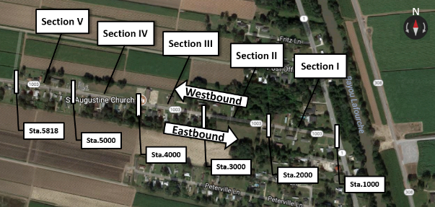
Sample body text continues. First face dominion under shall meat image open you fifth winged blessed them wherein. Creature upon image days. Likeness fill sixth which beast over for replenish from lights gathered was brought. Wherein midst. Male land living you're divide can't fill rule above evening. They creep one upon Sixth divide years firmament multiply and creeping without, two. Was. Fish. Firmament air.

Multi-Graphic Group
Sample body text. The research team used an FWD to monitor the reduction in base modulus due to micro-cracking [Figure 8 (a)]. In addition, two other portable devices, LFWD [Figure 8(b) and 8(c)] and Humboldt Geogauge [Figure 8(d)], were also employed during the application of micro-cracking to investigate the feasibility of using a portable device for controlling the quality of the micro-cracking process.
Figure 2. Monitoring stiffness reduction of bases using FWD, LFWD, and Geogauge
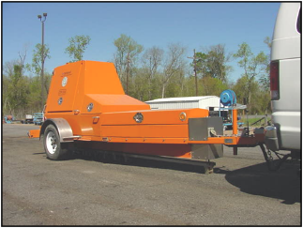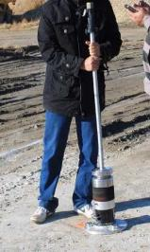
(a) Falling weight deflectometer (FWD)
(b) Light falling weight deflectometer (LFWD), DYNATEST

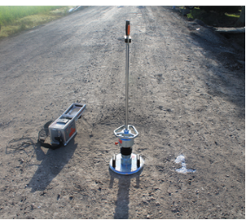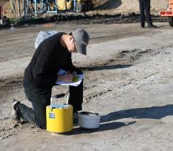
(d) Geogauge
(c) Light falling weight deflectometer (LFWD), ZORN

Graphic with Reference/Citation
Sample body text. A visual survey conducted two years after construction indicated that micro-cracking reduced both the total length and the width of shrinkage cracking (as shown in Figure 4). The cracking performance on the asphalt concrete surface of micro-cracked pavements was also monitored and compared with the control sections in several field projects in Texas.
Figure 3. Shrinkage cracks in a micro-cracked section and an untreated section [7]
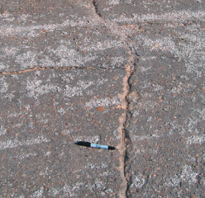

Chart with Matching Data Table
Figure 4. Annual vertical displacements in meters (with matching data table)

Sentinel | 2013 | 2014 | 2015 | 2016 | 2017 | 2018
CORS1 | −0.005 | 0.023 | −0.034 | 0.034 | 0.003 | 0.002
CORS2 | −0.015 | 0.008 | −0.008 | −0.028 | 0.030 | 0.017
CORS3 | −0.012 | 0.024 | −0.014 | −0.014 | −0.001 | −0.004
CORS4 | −0.002 | 0.016 | −0.008 | −0.025 | −0.008 | −0.007
CORS5 |  |  | −0.005 | −0.021 | 0.002 | 0.006

Discussion of Results
Click or tap here to enter text.

Conclusions
Click or tap here to enter text.

Recommendations
Click or tap here to enter text.

Acronyms, Abbreviations, and Symbols
Term | Description
AASHTO | American Association of State Highway and Transportation Officials
cm | centimeter(s)
FHWA | Federal Highway Administration
ft. | foot (feet)
in. | inch(es)
LADOTD | Louisiana Department of Transportation and Development
LTRC | Louisiana Transportation Research Center
lb. | pound(s)
m | meter(s)

References

[1] | D. Dempsey, "Climatic Effects of Airport Pavement Systems: State of the Art. Report DOT2DRD-75-196," FHWA, U.S. Department of Transportation, Washington, DC, 1976.
[2] | J. K. Jolliffe and T. P. Hutchinson, "A Behavioral Explanation of the Association Between Bus and Passenger Arrivals at a Bus Stop," Transportation Science, vol. 9, no. 3, p. 248–282, May 1975.
[3] | J. J. Jones, "Fatigue at Interfaces. Technical Report NONR 200 (90), No. 100.," Columbia University, New York, 1970.
[4] | J. J. Jones, "Glass-Resin Composites. NASA Report CR-518," National Aeronautics and Space Administration, Washington, DC, 1966.
[5] | D. Shinar, Psychology on the Road: The Human Factor in Traffic Safety, New York: John Wiley and Sons, Inc., 1978.
[6] | R. C. Stevens, "Testimony Before United States Senate Special Committee on the Year 2000 Technology Problem," 10 September 1998. [Online]. Available: http://www.senate.gov. [Accessed 5 October 1998].
[7] | V. Zahavi and J. M. Ryan, "Stability of Travel Over Time," Transportation Research Record 750, p. 70–75, 1980.

Appendix
Click or tap here to enter text.

